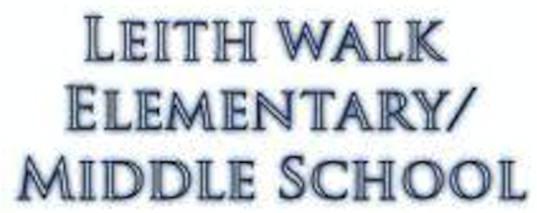

1235 Sherwood Ave, Baltimore MD 21239

From the desk of Mr. Peinert

Dear Parent or Guardian,

You are invited to a parent-teacher conference to discuss the progress of your student is making this year in Social Studies. Their grade for the quarter will be finalized on Nov 9th. Current grade and missing work is listed on the back that needs to be made up. Thanks and hope to hear back from you and see you on the 7th.

Join us on:

|  |
| --- |
| **Conference RSVP** |

Circle One Please

I will attend

 I will not attend, but please contact me to set up a conference at another time.

Parent Name:

_________________________________________

Contact #: ________________________________

Date- November 6, 2017

Time- 12:00pm – 2:40pm

Place- Mr. Peinert’s Room A123

Please fill out the RSVP and return it by:

**Friday, November 3, 2017**

Thank you and we look forward

to meeting with each of you.

COMMENTS:

Sincerely, Mr. Peinert