Australia Webquest
1. Complete the map and color France in blue and Australia in red.

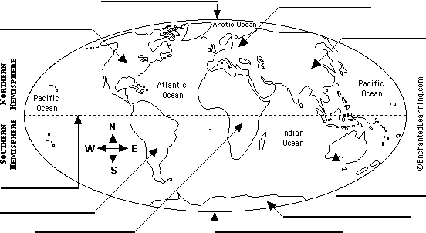

AFRICA – ANTARTICA – ASIA – AUSTRALIA – EQUATOR – EUROPE – NORTH AMERICA – NORTH POLE –
SOUTH AMERICA – SOUTH POLE
- Which hemisphere is Australia in ? ……………………………………………………………………………….

- So, when it’s winter in France, it’s ………………………………………… in Australia.

2. Complete the map of Australia.

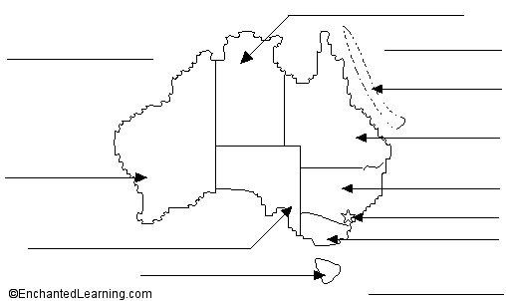 | 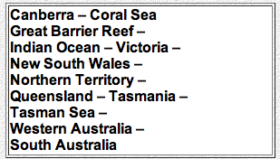
- Australia is composed of ………………… states and …………………. territories.

- What is the capital city of Australia ? …………………………………………………………………………….

- Which are the largest cities ?………………………………………………………………………………………

………………………………………………………………………………………………………………………….

- How many people are there in Australia ? …………………………………………………………………………

- What is the nickname of Australia ? Why ? ……………………………………………………………………….

3. Color the Australian flag.

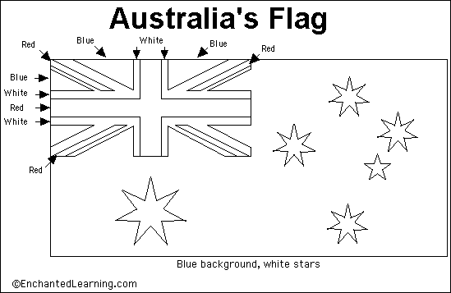

- Why is there the British flag on the upper left corner ? …………………………………………………………..

………………………………………………………………………………………………………………………….

- What do the 5 stars represent ? Why ? ……………………………………………………………………………

…………………………………………………………………………………………………………………………

- What does the Commonwealth star symbolize ? ………………………………………………………………….

………………………………………………………………………………………………………………………….

4. What is the currency in Australia ?

In France, we pay in euros ; In Australia, they pay in ……………………………………………………………….

5. Government in Australia. Page 1 - Page 2

- Who is the « Head of State » of Australia ? ……………………………………………………………………….

- Who represents her when she is not here ? ………………………………………………………………………..

- Who is the Head of the Government ? …………………………………………………..

6. The Aborigines. Page 1 - Page 2

- Who are they ? ……………………………………………………………………………………………………

- Look at the Aboriginal flag : | 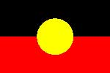
The black represents ………………………………………………………………………………………………..

The red represents ………………………………………………………………………………………………….

The yellow represents ………………………………………………………………………………………………

- What’s a « didgeridoo » ? ………………………………………………………………………………………….

- What was a boomerang used for ? …………………………………………………………………………………

7. Ayers Rock.

- What’s the Aboriginal name of it ? ………………………………………………………………………………

- Why is it so important for the Aborigines ? ………………………………………………………………………

………………………………………………………………………………………………………………………..

- How high, how old and how long is it ? ……………………………………………………………………………

8. The Flying doctors.

- Who are they ? …………………………………………………………………………………………………….

- What do they do ? ………………………………………………………………………………………………….

9. Alice Spring School of the Air. Page 1 - Page 2 - Page 3

- What is it ? ………………………………………………………………………………………………………….

…………………………………………………………………………………………………………………………..

10. The animals.

- Write the names of these Australian animals.

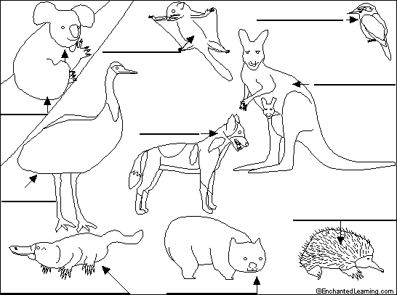 | 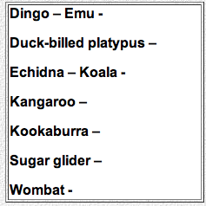
- What are « dingoes » ? ………………………………………………………………………………………….

- Where do they live ? …………………………………………………………………………………………….

- What do they eat ? ………………………………………………………………………………………………

- Choose an Australian animal, click on it to get information and write a few lines about it. ……………………

…………………………………………………………………………………………………………………………

…………………………………………………………………………………………………………………………

11. Geography and tourism. Page 1 - Page 2

- What is the « outback » ? ………………………………………………………………………………………….

- What is there in the outback ? ……………………………………………………………………………………

- What can you see in Sydney ? ……………………………………………………………………………………

…………………………………………………………………………………………………………………………

- What’s the most famous scenic place near Cairns ? Page 1 - Page 2

…………………………………………………………….

12. Language. Page 1 - Page 2

The Australians speak English but some words or expresssions can be different : it’s the Australian slang.

Can you find the Australian slang words for these English words ?

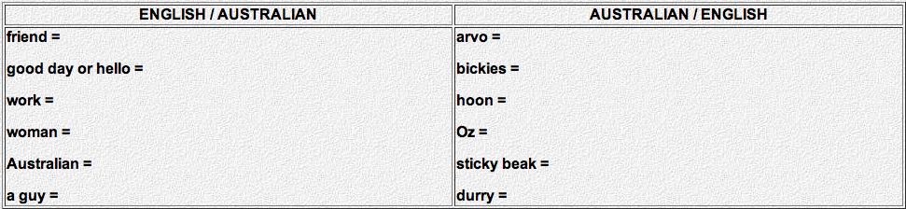

13. Sport.

The Australians are very sporty. What sports do they practise ?

