Middle Tier
NAME:_______________________ DATE:_______________________
Mr. Peinert’s Directions: Look over the Human and Physical features pictured below to answer the following question.
Rio de Janeiro, Brazil
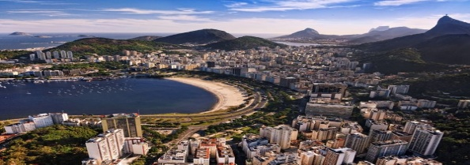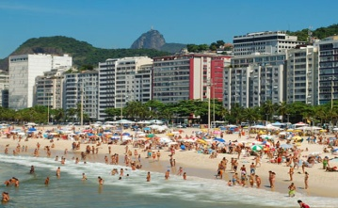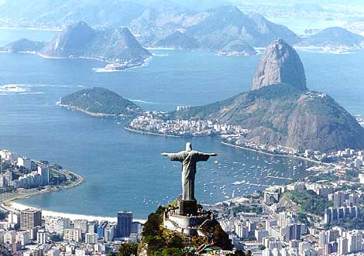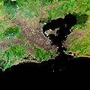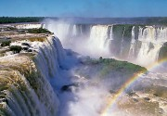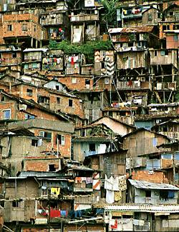
QUESTION: You are to review the pictures above from the country of Rio De Janeiro. You will then be asked to write a BCR describing the physical landscapes of the country. Make sure you are not confused with the human features that are pictured above. Use the remained of this paper and the back to answer your question. The grade will be based off of the BCR writing rubric.

